H.T No
Regulations:
A15


Sreenidhi Institute of Science and Technology
(An Autonomous Institution)
Code No: 5B518 Date: 01-June-2019 (AN)

B.Tech III-Year I-Semester External Examination, May/June-2019 (Supplementary)
DESIGN OF MACHINE MEMBERS-I (ME)

Time: 3 Hours Max.Marks:75

Note: a) No additional answer sheets will be provided.
b) All sub-parts of a question must be answered at one place only, otherwise it will not be valued.
c) Missing data can be assumed suitably.

Part - A Max.Marks:25

Answer all QUESTIONS.

1. | Discuss the steps in design of a mechanical component. | [3M]
2. | Describe the causes of stress concentration. | [3M]
3. | List out various types of shaft couplings. | [3M]
4. | What is nipping in a leaf spring? | [3M]
5. | Differentiate between permanent joint and temporary joint. | [3M]
6. | Compare strength of a longitudinal and transverse welded joint. | [2M]
7. | What is the meant by surge in springs. | [2M]
8. | What is the difference between coupling and a joint? | [2M]
9. | Enumerate single and double shear failure of a rivet. | [2M]
10. | Give different types of fits used in manufacturing process. | [2M]
Part – B Max.Marks:50
ANSWER ANY FIVE QUESTIONS. EACH QUESTION CARRIES 10 MARKS.

11. |  | A hollow shaft is required to transmit 600 kW at 110 r.p.m., the maximum torque being 20% greater than the mean. The shear stress is not to exceed 63 MPa and twist in a length of 3 metres not to exceed 1.4 degrees. Find the external diameter of the shaft, if the internal diameter to the external diameter is 3/8. Take modulus of rigidity as 84 GPa. | [10M]
12. | a) | A 50 mm diameter shaft is made from carbon steel having ultimate tensile strength of 630 MPa. It is subjected to a torque which fluctuates between 2000 N-m to – 800 N-m. Using Soderberg method, calculate the factor of safety. | [7M]
 | b) | Describe the S-N curve with a neat sketch. | [3M]
13. |  | Design and draw a protective type of cast iron flange coupling for a steel shaft transmitting 15 kW at 200 r.p.m. and having an allowable shear stress of 40 MPa. The working stress in the bolts should not exceed 30 MPa. Assume that the same material is used for shaft and key and that the crushing stress is twice the value of its shear stress. The maximum torque is 25% greater than the full load torque. The shear stress for cast iron is 14 MPa. | [10M]
14. | a) | Sketch and explain the working of a leaf spring of an automobile. | [3M]
 | b) | Design a helical compression spring for a maximum load of 1000 N for a deflection of 25 mm using the value of spring index as 5. The maximum permissible shear stress for spring wire is 420 MPa and modulus of rigidity is 84 kN/mm². | [7M]
15. |  | A bracket is riveted to a column by 6 rivets of equal size as shown in Fig. It carries a load of 60 kN at a distance of 200 mm from the centre of the column. If the maximum shear stress in the rivet is limited to 150 MPa, determine the diameter of the rivet.  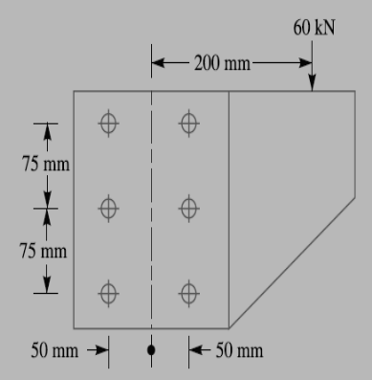 | [10M]
16. |  | A rectangular cross-section bar is welded to a support by means of fillet welds as shown in Fig. Determine the size of the welds, if the permissible shear stress in the weld is limited to 75 MPa.  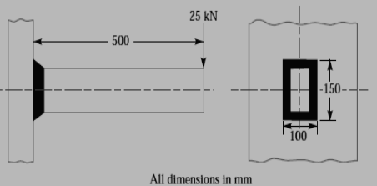 | [10M]
17. |  | Design a sleeve and cotter joint to resist a tensile load of 60 kN. All parts of the joint +-are made of the same material with the following allowable stresses :σt= 60 MPa ; τ = 70 MPa ; and σc= 125 MPa. | [10M]
18. |  | 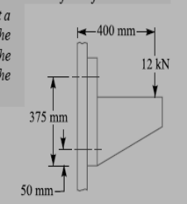  For supporting the travelling crane in a workshop, the brackets are fixed on steel columns as shown in Fig. The maximum load that comes on the bracket is 12 kN acting vertically at a distance of 400 mm from the face of the column. The vertical face of the bracket is secured to a column by four bolts, in two rows (two in each row) at a distance of 50 mm from the lower edge of the bracket. Determine the size of the bolts if the permissible value of the tensile stress for the bolt material is 84 MPa. | [10M]

-- 00 -- 00 –

